1. **Hello world program:**

**Ex.js**

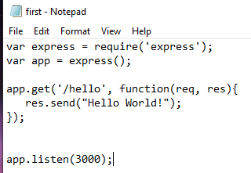

1. **HTTP Get Method:**

Ex.js

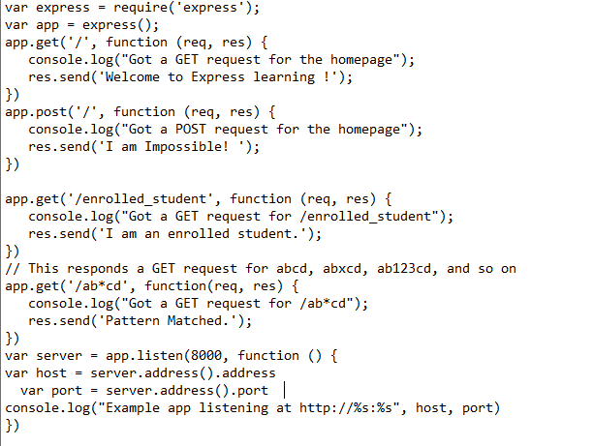

Output:



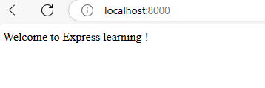

Now add root

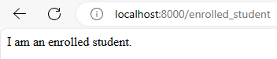

Now any pattern within abcd

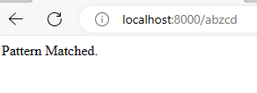

1. **URL binding (Dynamically passing the root value)**

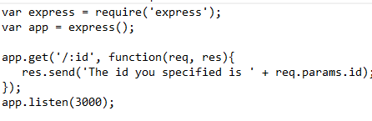

Output:

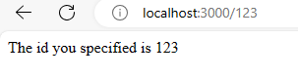

Urr.js:

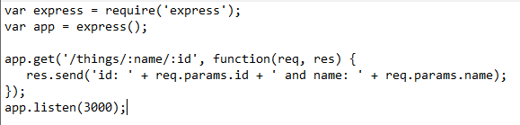

Output:

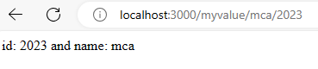

1. **Cookie example**

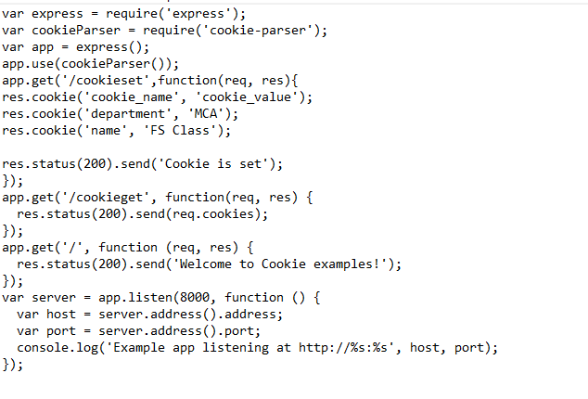

Output:

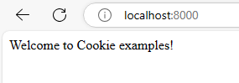

To set a cookie:

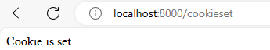

To get cookie:

